Environmental Science Web Quest-Biology

Name: ___________________________________Hr___Date________
Put your answers in a different color font.

I. BIODIVERSITY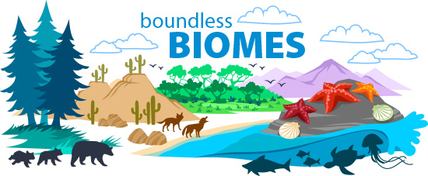

VI. BIOMES
Go to http://mbgnet.mobot.org/ and answer the following questions.
- What are the 6 Biomes of the World?
  - __________________________
  - __________________________
  - __________________________
  - __________________________
  - __________________________
  - __________________________
- What are the 3 Freshwater Ecosystems and the 3 Marine Ecosystems?
  - Freshwater:

  - Marine:

- Click on one of the six biomes. Choose one topic from the left column.

Write 3 sentences describing this topic. Do not copy word for word!

1. _______________________________________________________

_______________________________________________________
2. _______________________________________________________

_______________________________________________________

3. _______________________________________________________

_______________________________________________________

II. FOOD CHAINS

Answer the questions below: Use terms that we talked about in our notes last class.

- A person is called a(n) _____________________________________ because they eat meat & vegetables.
- Food gives people and animals __________________________________.
- ________________________ are animals that only eat meat.
- ________________________ are animals that only eat plants.

III. FOOD WEBS

Go to http://www.harcourtschool.com/activity/food/food_menu.html and choose one of the three food webs. Put the food web together! Use the red terms down below to fill in the box.

___________________– are living things that need producers to be their food (animals and people)
_________________– living things which take the non living matter from the environment (plants)
___________________– living things which feed off of dead plants and animals (bacteria, fungi)

Using the information in the table above answer the following questions about your food chain:
- Name a consumer in your food web _______________________________
- Name a producer in your food web ________________________________
- Name a decomposer in your food web ______________________________

IV. RELATIONSHIPS

Search the internet to complete the following:

- List the three types of symbiotic relationships:
  - ____________
  - ____________
  - ____________
- Give an example from nature of each of these types of relationships, and explain how each fits that relationship:
  - ____________________________________________________________________________________________________________________________________
  - ____________________________________________________________________________________________________________________________________
  - ____________________________________________________________________________________________________________________________________

V. POPULATION

Go to http://www.geography4kids.com/files/land_population.html and answer the following questions:

- What is a population? ________________________________________________________________________________________________________________________________________

- Two things that increase a population

  - ______________________________________________
  - ______________________________________________
- Two things that decrease a population:
  - ______________________________________________
  - ______________________________________________

Choose and read about one of many impacts that humans have on ecosystems from the list below:

Impact of Human Activity on Ecosystems
 | Human Soil Erosion
Pollution | Greenhouse Effect

List two facts you learned about the impact you chose:

1. _______________________________________________________
2. _______________________________________________________

V. (pt 2)POPULATION:
Go to: http://www.nhptv.org/natureworks/nwep12.htm

- Read the paragraph about populations, then click on “limiting factors”.
- List three abiotic things that would limit a population size:
  - ___________________________________
  - ___________________________________
  - ___________________________________
- List three biotic things that would limit a population size:
  - ___________________________________
  - ___________________________________
  - ___________________________________
- How can predator-prey relationships affect population size?

VI. Ecosystem and Energy WebQuest

- Go to http://www.zephyrus.co.uk/foodpuzzlechain.html
and complete the food chain “quiz.”
Make sure to answer these questions as you go. [In other words, all of these questions can be
answered by the information found as you work through this quiz.]

a. Green plants make their own food, so they are called _______________________.

b. What is a predator?

c. What is an example of a producer that fish could eat?

d. What is the general term for organisms that live in soil and fallen leaves on the forrest
floor? What is one example of them?

- Go to https://sciencebob.com/what-is-the-difference-between-food-chain-and-a-food-web/

and answer this question: What is the difference between a food chain and a food web?

- Go to http://www.vtaide.com/png/foodchains.htm
to answer these questions.
a. In any ecosystem, there are fewer carnivores than herbivores. Why? [Your answer needs
to specifically include a description of how energy is transferred.]

b. Why would it be extremely rare to find a food chain with nine links in it?

